PERSONAL PROFILE
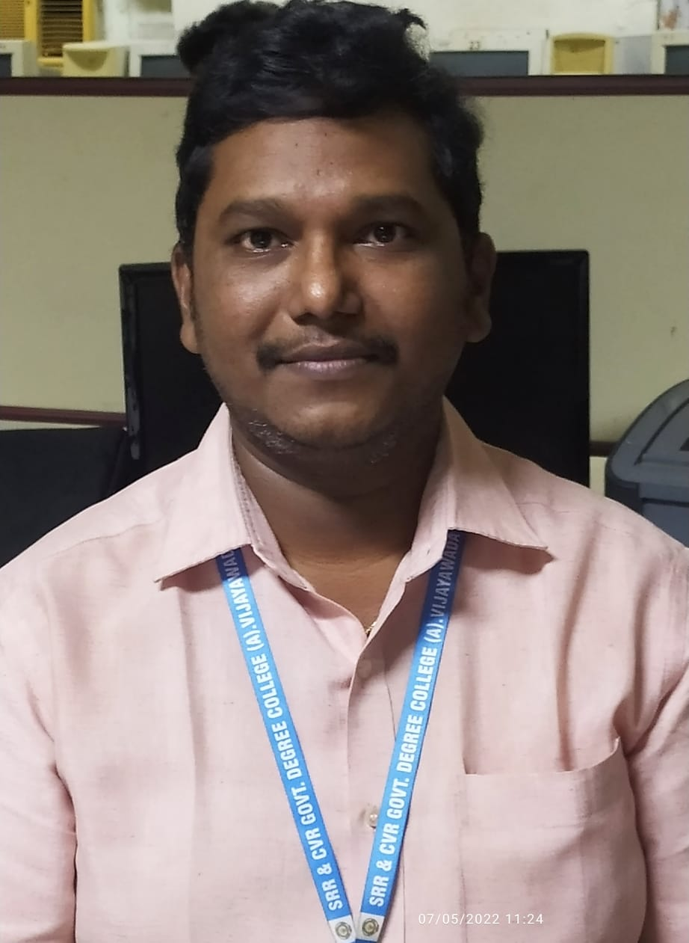

Name: VIJAYADEEP GUMMADI
Designation: Lecturer and In-Charge
College Address: SRR & CVR GDC (A) Vijayawada
Cell No: 9030561156
Mail Id: vijayadeep.gummadi@gmail.com

Educational Qualifications
S.NO | COURSE | BOARD / UNIVERSITY | YEAR OF PASS | PERCENTAGE
1 | M.Tech(CSE) | Visvesvaraya Technological University | 2010 | 74.5
2 | B.Tech(CSE) | JNTU Hyderabad | 2003 | 61.35
3 | Intermediate | Board of Intermediate Education | 1999 | 76
4 | SSC | Board of Secondary School Education | 1997 | 75.83

Professional Experience:
- Working as Lecturer and In-Charge of Computer Science department of SRR & CVR Government Degree College(A), Vijayawada from 24-09-2021 to till date.
- Worked as Lecturer and In-Charge of Computer Science department of YVNR Government Degree College, Kaikaluru from 06-06-2018 to 23-09-2021.
- Worked as Associate Professor of Computer Science and Engineering department in Gudlavalleru Engineering College, Gudlavalleru from 01-07-2012 to 31-05-2018.
- Worked as Assistant Professor of Computer Science and Engineering department in Gudlavalleru Engineering College, Gudlavalleru from 01-09-2005 to 16-08-2007 and 08-06-2009 to 30-06-2012.

Achievements
- Secured All India 3828 rank in GATE-2007
- Secured 5th rank in ANU Ph.D entrance examination 2013
- Selected through APPSC for the post of Lecturer in Computer Science in 2018
- Secured 1st mark(BCC Category) in the exam conducted for the post of Lecturer in Computer Science in 2018
Memberships:
- Life Member of Computer Society of India

In service programs attended:

Research Experience : Article published:

Conferences at International level: NIL
.
Conferences at National level: NIL

Conferences at State Level: NIL

Workshops attended

Administrative Experience
- Serving as Incharge of the department from 24-09-2021 to till date at SRR & CVR Government Degree College(A), Vijayawada.
- Served as Incharge of the department from 06-06-2018 to 23-09-2021 at YVNR Government Degree College, Kaikaluru.
- Served as Department Examinations coordinator at Gudlavalleru Engineering College(A), Gudlavalleru during the period 01-07-2012 to 31-03-2018.
- Served Department NBA coordinator at Gudlavalleru Engineering College(A), Gudlavalleru during 1st and 2nd cycles.

